A NEW CULINARY ADVENTURE BEGINS IN THE VILLAGE OF KLEINBURG, ONTARIO

Seasoned Chef Gino Guercio brings a creative Italian-inspired menu
to Vaughan’s historic village
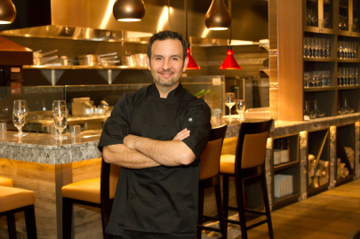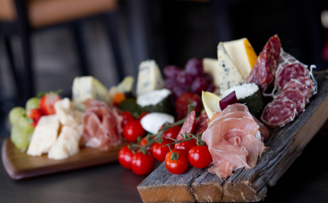
KLEINBURG, ONTARIO, January 2016 – There is no better location for a memorable get together than Belsito Trattoria-Vino, a new restaurant in the historic Village of Kleinburg that offers a creative culinary concept and a delectable menu that fuses tradition with innovative cooking techniques, combining authentic Mediterranean ingredients with premium local and imported products.

Belsito Trattoria-Vino is the creation of experienced Chef Gino Guercio. Honoring his Italian heritage, the restaurant was named after his ancestral home of Belsito, located in the province of Cosenza, Italy. Inspired by the innate culinary talent of his mother and many aunts and uncles, Chef Gino spent his childhood in the kitchen, learning recipes that are still prepared for family gatherings. At a young age, Chef Gino discovered his passion in the kitchen, starting his career at age 14. He graduated from the George Brown College of Hospitality, wining several awards, including the Gold Medal in Le Salon Culinaire competition and a Silver medal in the Taste of Canada. For almost three decades, Chef Gino has held progressive executive roles in the culinary divisions of luxury brands, including the Four Seasons, Fairmont, Delta and Intercontinental hotels in Canada, Mexico and Japan, managing a multitude of restaurants with almost every culinary concept.

Chef Gino has relocated from Tokyo to Kleinburg to open Belsito Trattoria-Vino. “I am very excited to see the result of many months of planning, and can’t wait to welcome patrons to my new restaurant.” said Chef Gino. “Belsito offers dinner, lunch and weekend brunch right in the charming Village of Kleinburg, steps from the McMichael Art Gallery, the Kortright Center for Conservation and the Humber River Trails. The menu showcases recipes that my family has prepared for generations, and a selection of my favorite Italian dishes.” Chef Gino has travelled to over 30 countries, always in search for the next food trend, while keeping in mind that traditional recipes will always have a special pace in the culinary world and in his heart.

Menu highlights include baccala fritto alla belsitese (salted cod with a warm tomato, caper & chive salsa), orecchiette alla Calabrese, "Napoléon" di filetto di manzo (8oz. Alberta Black Angus filet mignon layered with rosti potatoes & grilled asparagus, barolo red wine jus), the linguine frutti di mare "al cartoccio" (wrapped in a savoury pizza dough and baked in the Napolitano oven) and much more!

Belsito Trattoria-Vino offers a vast selection of wines, with a focus on Italian varieties. The restaurant has 76 seats, in addition to an al-fresco seasonal patio with capacity for 34 guests. The venue can be booked for private events. Catering service available.

For more information, please visit www.belsitotrattoria.com

###

About Belsito Trattoria-Vino
Opening on January 12, 2016, Belsito Trattoria-Vino is an Italian inspired restaurant located in the picturesque Village of Kleinburg, Ontario. Featuring a creative menu crafted by Executive Chef and Owner Gino Guercio, the restaurant honours his Italian heritage, and is the ideal place to socialize and celebrate while savouring an innovative lunch, dinner or weekend brunch. With 76 indoor and 34 outdoor seats, the restaurant can also be booked for private events. For reservations, please call (905) 552 7555 or visit belsitotrattoria.com
Become a fan! Facebook.com/BelsitoTrattoria, Instagram.com/BelsitoTrattoria

For media inquiries, please contact:
Beatriz Fuentes
Marketing & Public Relations
Direct: 905-203-2534
E-mail: beatriz@bbfmarketing.com

